Animal Kingdom Classification
Animals are characterized being multicellular and eukaryotic. Classification of animals is about organizing organisms into groups. Members of a group have shared characteristic, that is common to all members of that group and it is this character that defines the group.
There are about 1.2 million species of animals identified and there are almost 9-10 million species of animals on earth. This huge population of animals creates importance for the need of classification. Classification helps in assigning a systematic position to newly described species.

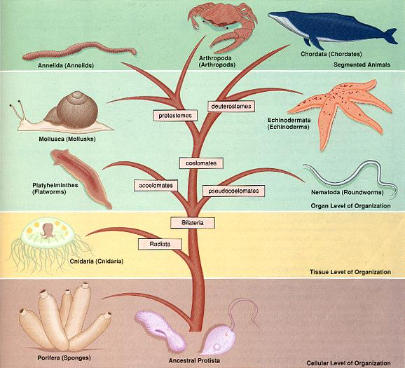

Characteristics of Animal Kingdom Classification

Basis of Classification

There is a difference in structure and form of different animals, there are a few fundamental characteristics that are common to various organisms. The features are
- Arrangement of cells,
- Body symmetry,
- Nature of coelom,
- Patterns of digestive, circulatory and reproductive systems,
- Arrangement of cells in germ layers,
- Segmentation,
- Notochord. These are the features that forms basis for animal classification.

Levels of Organisation

All the organisms of the Animal kingdom are multicellular but they do not exhibit the same pattern if organization of cells.
The patterns of cellular organization seen in animals are:

- Cellular Level of Organization - In these animals the cells are arranged in the form of loose cell aggregates. This kind of cellular organization is seen in sponges.Example: Sponges.
- Tissue Level of Organization - Cells of the animals show division of activities among themselves. Cells performing the same function are arranged as tissues. Example: Coelentrates.
- Organ Level of Organization - Tissues of the animals performing the similar function are grouped to form organs. Each organs is specialized for specific function. Example: Platyhelminthes.
- Organ system Level of Organization - In animals where organs have associated to form functional systems where each system is concerned with a specific physiological function are said to exhibit organ system level of organisation. Example: Annelids, Arthropods, Molluscs, Echinoderms and Chordates.
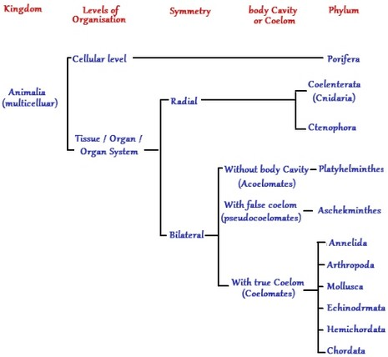

Patterns of Organ Systems

Organs systems in different groups of animals exhibit various patterns of complexities.
- Digestive System - There are two patterns of digestive system incomplete and complete digestive system.
Incomplete digestive system - This pattern of digestive has only one opening to the outside of the body, i.e., a single opening serves as both mouth and anus. Example: Platyhelminthes.
Complete digestive system - In this pattern there are two opening to the outside of the body, the mouth and the anus. Example: Arthropods, Chordates, etc.
- Circulatory System - Circulatory system may be of two types - open type and closed type.
Open type - In open type circulatory system the blood is pumped out of the heart and the cells and tissues are directly bathed in it.
Closed type - In this type of circulatory system the blood is circulated through a series of vessels of varying diameters - the arteries, veins and capillaries.

Body Symmetry

Animals can be categorized on the basis of their body symmetry. The arrangement of body parts around a central point or line determines the symmetry.
- Asymmetrical - some animals cannot be divided into two equal halves along any plane passing through the center of the organism. Asymmetry is the complete absence of symmetry. Example: Sponges.
- Radial Symmetry - Animals are said to exhibit radial symmetry, when any plane passing through the central axis of the body divides the organism into two identical halves. Example: Coelentrates, ctenophores and echinoderms.
- Bilateral Symmetry - Animals where body can be divided into identical right and left halves are said to be bilaterally symmetrical. Example: Annelids, Arthropods,etc.
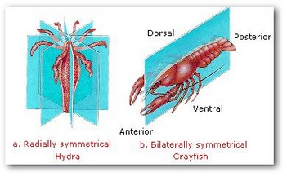

Body Wall

Body wall of animals are arranged in two or three embryonic layers. Accordingly animals are diplobalstic or triploblastic.

- Diploblastic Animals - Animals in which the cells are arranged in two embryonic layers are known as diploblastic animals. Diploblastic animals have an external ectoderm and an internal endoderm. The middle mesoglea is the middle undifferentiated layer present between outer ectoderm and middle mesoderm. Example: Coelentrates.
- Triploblastic Animals - Triploblastic animals are those, whose cells are arranged in three germinal layers, the outer ectoderm, inner endoderm and the third germinal layer mesoderm which is in between outer ectoderm and the endoderm. Example: Platyhelminthes to Chordates.
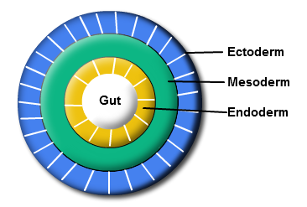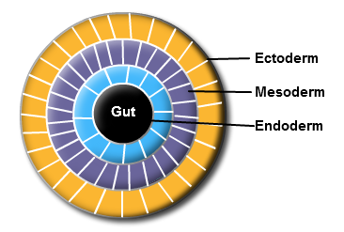

Nature of Coelom

The presence or absence of a cavity between the body wall and the gut wall is important characteristic for classification. Coelom is the body cavity that is lined by the mesoderm. There are three types of animals based on the type of coelom - coelomates, pseudocoelomates or acoelomates.

- Acoelomates - Animals in which the body cavity is absent are known as acoelomates. Example: Platyhelminthes.
- Pseudocoelomates - Animals in which the body cavity is not lined by the mesoderm, instead the mesoderm is present in scattered pouches in between the ectoderm and the endoderm are known as the pseudocoelomates. Example: Aschelminthes.
- Coelomates - Animals possessing the body cavity which is lined by the mesoderm are known as coelomates. Example: Annelids, Mollusca, Arthropods, Echinoderms, chordates.
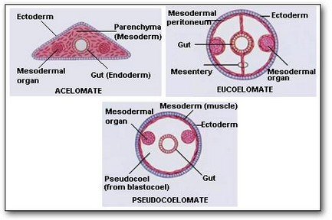

Segmentation
In some animals, body is segmented externally and internally, with serial repetition of at least some organs. This phenomenon is known as metamerism and the segmented body pattern is known as metameric segmentation. Example: Earthworm.

Notochord
In some animals during embryonic development, a mesodermally derived rod-like structure is formed on the dorsal side, this is known as notochord. Animals with notochord are known as chordates and the animals which do not form notochord are known as non-chordates. Example: Porifera to Echinoderms.

Animal Kingdom Classification System
There are many different types of animals which are similar and different to each other in many aspects. Members of a particular group of animal share a particular characteristic that is common to all the members of the group. This is the feature that defines the group.
Biologists arrange organisms into groups on the basis of traits which they share with other animals and the genetic relationship with each other. This orderly form of classification of animals is the basis of taxonomy. Modern taxonomy is based on physical characteristics and genetic characteristics. Systematics is the field of study that focuses on evolutionary relationships between living organisms.
Carlous Linnaeus (1707-1778), a Swedish botanist was the inventor of modern scientific classification. He designed his system of classification so that each animal and plant he described had only one name and this name would not be shared with any other organism.
The system most scientist use put each living thing into seven groups or taxons. They are organized from most general to most specific category. These categories in the hierarchical system are from higher and most inclusive to lower to more specific are kingdom, phylum, class, order, family, genus and species.
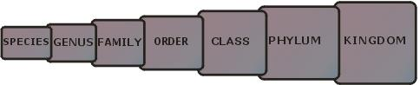
Kingdom is the highest primary division in which all objects are placed. All animals are part of the Animal Kingdom.
Phylum - Each kingdom is divided into smaller units called phyla. Example, chordates are a phylum with members possessing the nerve cord.
Class - The chordates are further divided into classes such as Mammalia, Birds, Reptilia, Amphibians. Members of each class have a characteristics that they share with the members of the same class but are not found in members of other classes.
Family - Classes are further divided into families. Families contain more than one genus.
Genus - Families are sub-divided into genera. Animals that share the same genus are very similar and probably evolved from the same common ancestor.
Species - Species is the most fundamental and contains single type of animal.

Animal Kingdom Classification Chart
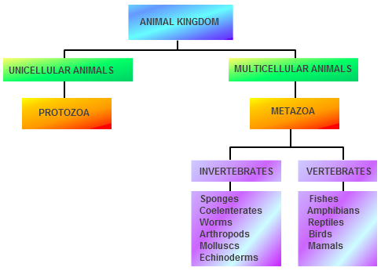
Animals are classified into two principal groups invertebrates (with-out backbone) and vertebrates (with backbone). Backbone is the observable feature which defines whether the animal is vertebrate or invertebrate.
Sponges, star fish, Obelia, worms, spiders, insects are the sub-groups of the invertebrate group, they do not have a backbone.
Fishes, birds, frogs, snakes and mammals have a backbone and are the sub-group of the vertebrate group.

Invertebrates
Invertebrates are the most abundant organisms on earth. They occupy almost all habitats, they can be found crawling, flying, swimming or floating. Invertebrates are the animals without backbone. These animals do not have internal skeleton made of bone. They play a vital role in the earth's ecosystem.

About 99 per cent of the known organisms are invertebrates. Out of the planets estimated 15-30 million species about 90% of the animals are invertebrates. These come in may shapes and sizes and provide services that are vital for our survival.

The most common vertebrates include sponges, annelids, echinoderms, molluscs and arthropods. Arthropods includes insects, crustaceans and arachnids.
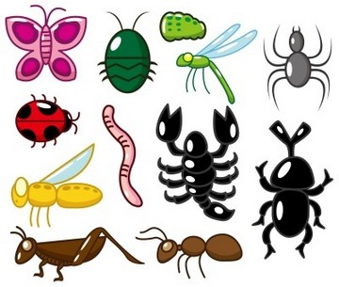

The earliest fossil of an invertebrates dates back towards the late Precambriam period, over 600 million years back.

What are Invertebrates?
Invertebrates are the animals that do not have a backbone or the vertebral column. Animals without the notochord are invertebrates. Most of the animals are invertebrates. The term invertebrates is a prefixed form of a Latin derived word 'Vertebra'. 'Vertebra' means joint in general, specifically it means 'the joint of the spinal column of the vertebrate'. It id coupled with the prefix "in" meaning not or without, which conveys the meaning 'those that lack vertebrae'.
Invertebrates are the most diverse group having about 12 million live species. Most of the animals on earth are invertebrates. They are cold-blooded animals; their body temperature depends on the temperature of the atmosphere.

Characteristics of Invertebrates
General characteristics of invertebrates are as follows:
- The main characteristic that separates invertebrates from other organisms is the absence of the spinal column and backbone.
- They are multicelluar organisms, they completely lack cell walls.
- They are devoid hard bony endoskeleton.
- Due to the lack of complex skeletal systems, some invertebrates tend to be slow and small in nature.
- Due to the lack of the backbone and complex nervous system the invertebrates cannot occupy multiple environments, though they are found in the harshest of the environments.
- Invertebrates live all over the world in various habitats.
- Body is divided into three parts - head, thorax and the abdomen.
- They do not have lungs for respiration.
- Respiration is through skin.
- Some invertebrate groups possess a hard, chitinous exoskeleton.
- Most of them have tissues, that are specific organization of cells.
- Most of them reproduce sexually by the fusion of the male and female gametes.
- Few invertebrates like the sponges are sedentary, but most of the organisms are motile.
- Most invertebrates are organized with symmetric body organization.
- They cannot make their own food, are heterotrophs.

List of Invertebrates
Invertebrates are the most diverse organisms present on earth. Almost 95% of the animal populations are of the invertebrates. Based on the International Union regarding Conservation of Nature at the time of 2009 more than 1.3 million invertebrates were identified. Invertebrates make up around 75% of the recognized species on Planet.

The actual number of invertebrates is unknown, there are several predictions that there may be tens of millions of invertebrates, majority being the insects. New species of invertebrates are being discovered regularly, another worrying fact is that there is insufficient information about these organisms, the invertebrates might be going extinct and the scientists would never know that they even existed.
Below are a list of invertebrates -
Crustaceans, Centipedes, Ants, Wasps, Spiders, Locusts, Honey bees, Termites, Cockroach, Grasshoppers, Crickets, Stick insect, Mantis, Crabs, Sponges, Star fish, Unio, Leeches, Earthworms, etc.

Invertebrates Classification
Some invertebrate phyla are:

Phylum Porifera (Sponges)
- Members of this phylum are commonly known as sponges.
- Habitat - They are mostly marine, few are found in fresh water.
- Body symmetry - mostly are assymetrical animals, no definite shape to the body.
- Level of organization - These are primitive animals, multicellular with cellular grade of organization.
- Motility - Adult sponges are sessile, that is they need a substratum to attach themselves to a surface and do not move.
- Mode of Nutrition - Due to the sessile nature, sponges are filter feeders.
- Digestion - Digestion is intracellular.
- Skeleton - The body of sponges is supported by a skeleton made of spicules or spongin fibres.
- Reproduction - Sexes are not separate, they are hermaphrodites. Hermaphroditism - condition where eggs and sperms are produced by the same individual. Sponges reproduces asexually by fragmentation and sexually by formation of gametes.
- Fertilization - Fertilization is internal.
- Development - Indirect development, having a larval stage which is morphologically distinct from the adult.
- Water transport or Canal system - Sponges have water transport system. Water enters through minute pores (ostia) in the body wall into a central cavity known as spongocoel. From the spongocoel water goes out through the osculum. This water system aids in food gathering, respiratory exchange and removal of wastes.
- Choanocytes - These are collar cells, they line the spongocoel and the canals.
- Examples: Sycon, Euspongia, Spongilla.
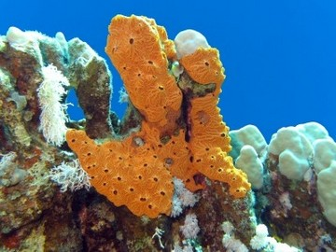

Phylum Cnidaria (Coelentrata)
- Habitat - They are aquatic mostly marine animals, they are sessile or free-swimming.
- Level of organization - They exhibit tissue level of organization.
- Body wall - They are diploblastic animals, body wall is made of 2 layers, outer ectoderm and inner endoderm.
- Body symmetry - They are radially symmetrical.
- Digestive system - They have a central gastro-vascular cavity with a single opening hypostome, which serves as both the mouth and the anus.
- Digestion is extracellular and intracellular.
- Specialized cells known as the cnidoblasts or cnidocytes which contain the stinging capsules or nematocytes are present on the tentacles and the body. Cnidoblasts are used for anchorage, defense and for the capture of prey.
- Some cindarians like corals have skeleton composed of calcium carbonate.
- Cnidarians exhibit two basic body forms called polyp and medusa. The polyp is a sessile form ann cylindrical in shape like the Hydra, Adamsia etc. The medusae form is umbrella shaped and free-swimming forms like Aurelia or jelly-fish.
- Metagenesis - Cnidarians which exhibit both polyp and medusae form are exhibit alteration of generation, this is known as metagenesis. Poplyps produce medusae asexually and medusae form the polyps sexually.
- Locomotion - The body contains nerve network that allows movement of tentacles and body.
- Examples: Aurelia (medusa), Adamsia (polyp).
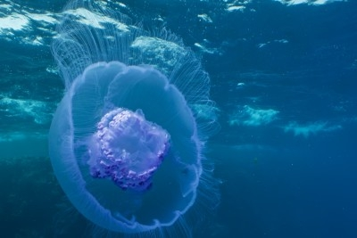

Phylum Ctenophora :
- Ctenophores are commonly known as sea walnuts or comb jellies.
- Habitat - They are exclusively marine animals.
- Body symmetry - They are radially symmetrical.
- Body wall - They are diploblastic organisms.
- Level of organization - Ctenophores exhibit tissue level of organization.
- Digestion is both extracellular and intercellular.
- Locomotion - The body bears eight external rows of ciliated comb plates, these help in locomotion.
- Bioluminescence is a property of living organism to emit light is well-marked in ctenophores.
- Reproduction - Sexes are not separate, reproduction is by sexual means only.
- Fertilization is external with indirect development.
- Example: Pleurobrachia

Phylum Platyhelminthes
- They are commonly called as flatworms, they have dorso-ventrally flattened body.
- Habit - They are mostly endoparasites found in animals and human beings.
- Habitat - Fresh-water and salt water; terrestrial.
- Body symmetry - Flatworms are bilaterally symmetrical.
- Body wall - They are triploblastic animals.
- Coelomic cavity - They are acoelomate animals
- Level of organization - Organ level of organization.
- Digestive system - In flatworms digestive system is incomplete, that is the digestive cavity has a single opening.
- Parasitic flatworms possess hooks and suckers to hold on to the body of the host. Some forms absorb nutrition directly from the host, through their body surface.
- Osmoregulation and excretion is carried out by specialized cells cells flame cells.
- Sexes are not separate.
- Fertilization is internal and development is indirect, having many larval stages.
- Some members like Planaria possess high regeneration capacity.
- Examples: Taenia (tapeworm), Fasciola (liver fluke).
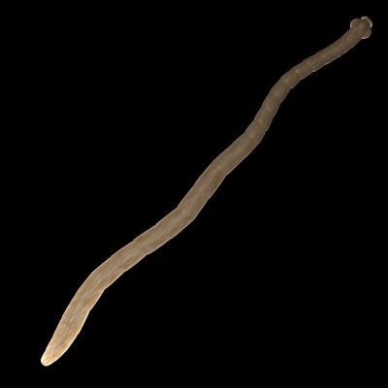

Phylum Aschelminthes (Nematoda)
- The body of worms of aschelminthes in cross-section is circular, hence the name round worms.
- Habitat - They may be free-living, aquatic and terrestrial or parasitic in plants and animals.
- Level of organization - Round worms have organ-system level of organization.
- Body symmetry - They are bilaterally symmetrical.
- Body wall - They are triploblastic animals.
- Coelomic cavity - They are pseudocoelomate animals.
- Digestive system - This is the first phylum to have a complete digestive system, with a well developed muscular pharynx.
- Excretory system - An excretory tube removes body wastes from the body cavity through the excretory pore.
- They are dioecious - the sexes are separate i.e., males and females are distinct. Often females are longer than the males.
- Fertilization is internal.
- Development may be direct - the young ones resemble the adult, or indirect.
- Examples: Ascaris (round worm), Wuchereria (filaria worm), Ancylostoma (hookworm).
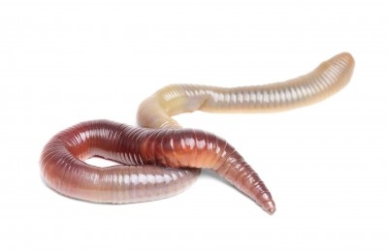

Phylum Annelida (Segmented worms)
- Habitat - They may be aquatic either marine or fresh water; or terrestrial; free-living and sometimes parasitic.
- Level of organization - They exhibit organ-system level of body organization and bilateral symmetry.
- Body wall - They are triploblastic.
- Coelom - They are coelomate animals.
- Body is metamerically segmented. The body surface is distinctly marked out into segments of metameres and hence, the phylum name Annelida.
- Locomotion - They possess longitudinal and circular muscles which help in locomotion.
- Aquatic annelids posses lateral appendages, parapodia which help in swimming.
- Circulatory system is closed.
- Osmoregulation and excretion is by Nephridia.
- Neural system - It consists of paired ganglia connected by lateral nerves to a double ventral nerve cord.
- Nereis is dioecious, but earthworm and leeches are monoecious.
- Reproduction is sexual.
- Examples: Nereis, Pheretima (earthworm), and Hirudinaria (blood sucking leech)
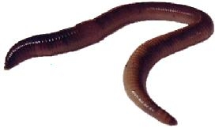

Phylum Arthropoda
- It is the largest phylum of the Animalia.
- It includes insects, spiders, crayfish, etc.
- Level of organization - They have organ-system level of organization.
- Body symmetry - They are bilaterally symmetrical.
- Body wall - triploblastic, segmented. Coelomate animals.
- The body of arthropods is covered by chitinous exoskeleton.
- Body is divided into head, thorax and abdomen.
- Jointed appendages - arthros - jointes, poda - appendages, hence the name is derived from this characteristic.
- All the arthropods have jointed appendages which give arthropods a wide range of controlled motions.
- Respiration is through organs like gills, book gills, book lungs or tracheal system.
- Circulatory system - It is of open type.Sensory organs are present, antennae, eyes (compound and simple), statocysts or balance organs are present.
- Excretion - It takes place through malphigian tubules.
- Mostly they are dioceious. Fertilization is usually internal.
- They are oviparous animals.
- Development may be direct or indirect.
- Examples: Honey bee, Silkworm, Lac insect, Mosquitoes, Locust, Crab
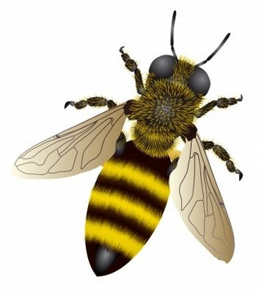

Phylum Mollusca
- It is the second largest phylum.
- Habitat - Molluscs are terrestrial or aquatic; they may be marine or fresh water.
- Level of organization - They have an organ-system level of organization.
- Body symmetry - Bilaterally symmetrical.
- Body wall - triploblastic. Coelomate animals.
- Body is covered by a calcareous shell.
- Body is unsegmented, they have a distinct head, muscular foot and visceral hump.
- The radula - Mouth of the molluscs contain tongue-like organ called radula, which has many rows of teeth, which is used to scrape food.
- Mantle - It is a fold of skin that surrounds the body organs.
- It is a soft and spongy layer of skin that forms a mantle over the visceral hump.
- The space between the hump and the mantle is called the mantle cavity.
- Feather like gills are present in this cavity.
- These gills have respiratory and excretory in functions. Anterior head region has sensory tentacles.
- Example: Pila, Octopus, Pearl oyster, Loligo, Sea-hare, Chiton.
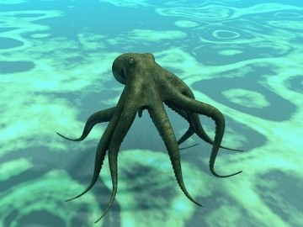

Phylum Echinodermata
- All the members are marine, live mainly on the ocean floor.
- These animals have an endoskeleton of calcareous ossicles, and hence the name echinodermata (spiny bodied).
- Level of organization - Organ-system level of organization.
- Body symmetry - The adults are radially symmetrical, but the larvae are bilaterally symmetrical.
- Body wall - Triploblastic. Coelomate animals.
- Digestive system is complete.
- The mouth is present on the ventral side and anus on the dorsal side.
- The most distinctive feature is the water vascular system.
- This helps in locomotion, capture and transport of food and respiration.
- Excretory system is absent.
- Sexes are separate.
- Reproduction is by sexual means.
- Fertilization is usually external.
- Development is indirect with free-swimming larva.
- Example: Star fish, Sea urchin, Brittle star.
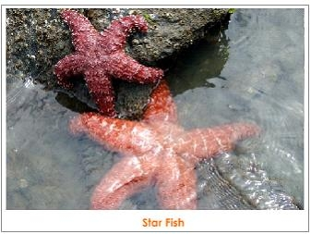

Examples of Invertebrates
Invertebrates include all animals that do not belong the phylum chordata. Common examples include clams, snails, spiders, cockroach, worms, star fish, octopus.
Porifera - Sponges, Sycon (scypha), Spongilla (fresh water sponge) and Euspongia (bath sponge).
Cnidaria - Aurelia, Adamis, Hydra, Sea anemones, Physalia (Portugese man-of-war), Pennatula (sea-pen), Gorgonia (sea-fan), Meandrina (brain coral).
Ctenophora - Pleurobranchia and Ctenophora.
Platyhelminthes - Taenia (tapeworm), Fasciola (liver fluke).
Aschelminthes - Ascaris (round worm), Wuchereria (filaria worm), Ancylostoma (hookworm).
Annelida - Nereis, Pheretima (earthworm) and Hirudinaria (blood sucking leech).
Arthropoda - Apis (honey bee), Bombyx (silkworm), Laccifer (lac insect); Mosquitoes - Anopheles, Culex and Aedes; Locusta (locust) ; Limulus (king crab).
Mollusca - Chaetopleura (Chiton), Loligo (squid), Pila (apple snail), Pinctada (pearl oyster), Sepia (cuttlefish), Loligo (squid), Octopus (devil fish), Aplysia (sea hare), Dentalium (tusk shell).
Echinodermata - Asterias (star fish), Echinus (sea urchin), Antedon (Sea lily), Cucumaria (sea cucumber), Ophiura (brittle star).

Vertebrates
Vertebrates are the most organized organisms on Earth. They belong to the sub-phylum Vertebrata. They are not the most numerous group of animals, they are the most advanced group of animals.The characteristics that makes vertebrates special are the presence of the spinal cords, vertebrae and notochords.
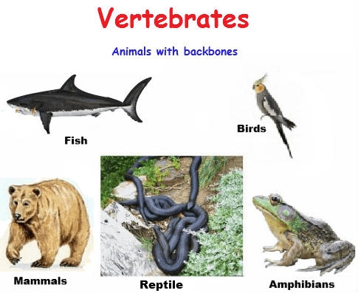

Most vertebrates have a very well developed nervous system. The vertebrates also have muscles and skeletons which help them move around efficiently and perform complex moves.
Â Vertebrates include the majority of the Phylum Chordata, having about 64,000 species described. Vertebrates make about 4% of all described species.

Vertebrates have a long history on earth - more than 500 million years, from the Cambrian era until date. First Vertebrates have said to be appeared around the Cambrian period of the Paleozoic era about 525 million years ago, they are said to be adapted to feeding algae in shallow waters and moving around from place to place.

Vertebrates Definition
Vertebrate are the animals belonging to the sub-phylum Vertebrata. They belong to the Phylum Chordata. The characteristics of phylum chordata is the presence of notochord, a dorsal hollow nerve cord and paired pharyngeal gill slits. The members of subphylum Vertebrata possess notochord during the embryonic period. The notochord is replaced by a cartilaginous or bony vertebral column in the adult. All vertebrate are chordates but all chordates are not vertebrates. Special characteristics of vertebrates other than the vertebral column are, they have a muscular heart which is two, three or four chambered. For excretion they have kidneys and appendages that are paired which may be fins or limbs.

Vertebrate Characteristics
General characteristics of the sub-phylum Vertebrata are as follows:
- Vertebrates have a well developed brain.
- Brain is set inside a bony box, known as cranium.
- Notochord is present in all chordates during sometime of development, it is formed on the dorsal side of the primitive gut in the early embryo stage.
- Most vertebrates possess guts with a non-terminal anus.
- The mouth cavity and the oesophagus is connected by the pharyngeal gill slits to a muscular tube pharynx, which opens to the exterior.
- They possess a dorsal hollow nerve tube at some stage of their life.
- Possess a dorsal cartilaginous nerve rod known as the notochord.
- At some stage of their life possess gill slits in the pharyngeal region.
- Have partially open circulatory system.
- Possess two pairs of appendages.
- The endoskeleton is made of cartilage or bone.
- The first vertebrates were jawless fishes with single caudal fin.
- The advancement of vertebrates with a hinged jaw which opened new food options and jawed fishes became the dominant creatures in the sea.
- All vertebrates have a heart and closed circulatory system.
- Reproduction is normally sexual.
- Feed on variety of organic materials.
- Unisexual animals, have one pair of gonads.

Vertebrate Classification

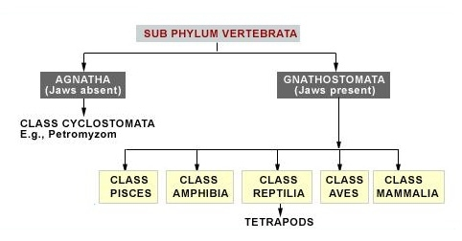

Classes of Vertebrates
Class - Cyclostomata
The living members of this class are all ectoparasites on some fishes. They have a elongated body. They bear 6-15 pairs of gills through which they respire. The mouth of the cyclostomes is sucking circular mouth without jaws. They do not have body scales and paired fins. The vertebral column and the cranium is cartilaginous. Circulation is closed type. These are marines organisms but they migrate to fresh water for spawning. After metamorphosis their larvae returns to the ocean.

Example: Petromyzon (Lamprey), and Myxine (Hagfish).
Class - Chondrichthyes

These organisms are marine and have streamlined body. The endoskeleton is cartilaginous. Mouth is located ventrally and the notochord is present throughout life. The gills are separate and are not covered by the operculum. The skin contains minute placoid scales. The placoid scales are modified as teeth and the jaws are powerful. They are predaceous animals. Air bladder is absent in these animals, hence, they have to swim constantly to avoid shrinking.

Example: Scolidon, Pristis, Trygon.
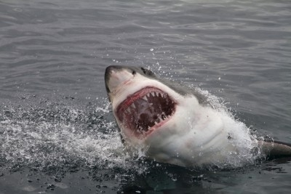
Class - Osteichthyes
This class includes animals that are both marine and fresh water fishes with bony endoskeleton. Their body is streamlined. Mouth is terminal in position. The gills are covered with operculum on each side and are in four pairs.The skin is covered by ctenoid/cycloid scales. Air bladder is present, it regulates buoyancy. Two-chambered heart is present, with one auricle and one ventricle. They are poikilothermic animals. The sexes are separate, fertilization takes place externally. Most of them are oviparous animals and development is direct, with no larval stages.
Example: Hippocampus, Clarias.
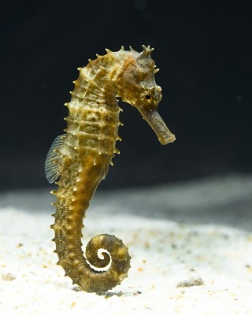
Class - Amphibia
The name Amphibia indicates - from Greek, Amphi meaning dual and bios meaning life.

Ampibians can live both in aquatic and terrestrial habitats. These animals have two pairs of limbs. Body is divisible into head and trunk and tail is present in some animals. The skin of these animals are scaleless and moist. The eyes have eyelids, and the ears are represented by a tympanum. Cloaca is a opening to the exterior, it is a common chamber for the alimentary canal, urinary and reproductive tracts.Gills, lungs and skin aids in respiration. Heart is three-chambered. They are cold-blooded animals. Sexes are separate, fertilization is external. They are oviparous animals and development is indirect.

Example: Toad, frog, salamander.
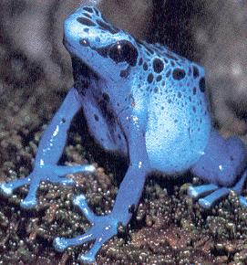
Class - Reptilia
In Latin repere or reptum means to creep or crawl, hence, the class name refers to locomotion that is of creeping or crawling mode.

These animals are mostly terrestrial and their body is covered dry and cornified skin, epidermal scales or scutes. External ear opening is absent, tympanum represents the ear. Limbs, if present are of two pairs. Usually heart is three-chambered, but is four chambered in crocodiles. They are poilkilothermic animals. Some animals like the snake and the lizards shed their skin. Sexes are separate, internal fertilization takes place. They are oviparous and development is direct.

Example: Turtle, Chameleon, crocodile.
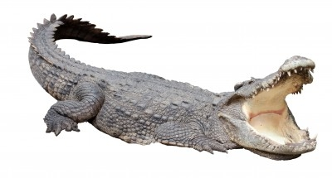
Class - Aves
Most of the members can fly, except the flightless birds. The characteristic feature of birds is the presence of feathers. The forelimbs are modified as wings. The hind limbs are modified for walking, swimming or clasping and generally have scales. The skin is dry and does not have glands, except a oil gland at the base of the tail. Endoskeleton is bony, and the bones are hollow with air cavities known as pneumatic bones. Heart is four-chambered completely. They are warm-blooded animals. Lungs are the organs of respiration. Sexes are separate, fertilization is internal. They are oviparous animals and development is direct.

Example: Crow, Pigeon, Parrot etc.
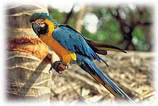
Class - Mammalia
Mammals are present in almost all habitats - polar ice caps, deserts, mountains, forests, and grasslands.The unique characteristic of the class mammalia is the presence of milk producing glands (mammary glands), by which the young ones are nourished. The limbs are of two pairs. The skin is covered with hairs. External ear 'pinna' is present. Heart is four-chambered and they are homeothermic animals. Respiration is through lungs. Sexes are separate and fertilization is internal. They viviparous animals, with direct development.

Example: Kangaroo, Tiger, Lion, Platypus etc.

List of Vertebrates
The vertebrates are a very diverse group of animals ranging from Hag-fish to Man. There are not the most numerous group of animals. Vertebrates are interesting because we are intimately familiar with them, or species Homo sapiens is included within the sub-phylum vertebrata. Vertebrates are easy to find as we co-exist with them and often aware of their presence in our environment.

Below are the list of few very familiar vertebrates: deer, fish, dogs, cats, birds, snakes, lizards, kangaroo, bears, foxes, wolves, bat, monkeys, eagles, penguins etc.

Examples of Vertebrates
Below are the examples of vertebrates:
Pisces: Sharks, trouts, eels, tunas, seahorse, pirahnas, salmons, etc.
Amphibians: Salamanders, frogs, toad, newts, caecilians, etc.
Reptiles: Snakes, lizards, tortoise, turtles, crocodiles, gharials, alligators, etc.
Birds: Penguins, emu, eagles, ostrich, parrot, crow, pigeon, ducks, owls, kites, robins, woodpeckers, albatross etc.
Mammals: Kangaroo, echidna, platypus, bats, mice, tigers, moles, dolphins, whales, deer, gorrilas, lemurs, rabbits, wolves, lions, leopards, jackals, etc.

