BASIC COMPONENTS AND FUNCTIONS OF A COMPUTER
This class discusses the main components and the basic functions, operations, and characteristics of a computer.
The computer is an electronic data processing device, which requires input raw data for processing and generates the output in desired form. It stores the data in its memory which can be accessed any number of times for reference from its memory. It is made up of a lot of electronics, software, and mechanical parts.
The computer is recognized as a system; it is a system because it is a collection of interrelated parts (components) which work together to achieve the goal(s) of the operator.
The interrelated parts which are professionally referred to as components or devices are classified into four namely;
Input devices,
Processing devices,
Output devices, and
Storage devices.
The aforementioned components are so named in line with the various functions they perform, therefore, the main functions of the computers are;
Data input function,
Data processing function,
Information output function, and
Data and information storage function.
Hence, the computer performs four main functions which includes take data and instructions from a user, process the data as per instructions, display, and store the processed data
The following diagrams show an example of these devices and functions.
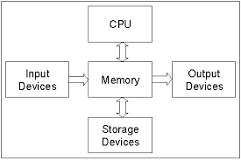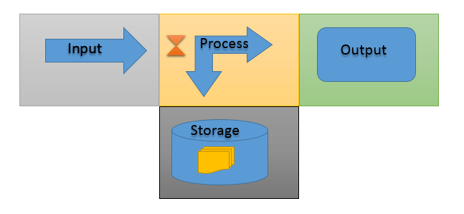
To provide these functions, a computer uses its components or devices. Usually, components of a computer are designed to perform only one of these four functions. But, some specialized components or devices are designed to perform two, three or all four functions. For example, a hard disk can perform three functions: input (when files are read), storage (when files are saved), and output (when files are written).
Components or devices of a computer, based on the function in which they are used, can be classified into four major types: the input devices, output devices, storage devices, and processing devices. For example, if a component processes the given instructions, the component is known as the processing device. Or if a device displays the processed data, the device is known as the output device.
Input function and devices
A computer is a data processing machine. It does nothing until a user (or a script or a program) provides the data that needs to be processed and the instructions that tell it how to process the data.
Any standard device or component that a user uses to instruct a computer is known as the standard input device. In other words, a computer uses its standard input devices or components to get instructions from a user.
The most common input devices are the keyboard and mouse. Almost all modern computers have these devices. Other common input devices are scanners, microphones, USB drives, and webcams.
Input data and instruction can also be generated from a non-standard input device such as the hard disk and CD/DVD. For example, a batch file in the Windows system may instruct the CPU to execute a program or a script at a particular time.
Installation disks are another good example of non-standard input devices. Usually, they contain a script or an executable program that automatically starts the installation process as soon as the disk is read.
Process function and devices
Once the data and instructions are received by the input function, the computer starts the processing function. In this function, a computer processes the received data according to the instructions.
To process the input data according to the instructions, the computer uses the CPU. A CPU is the main processing component of a computer. It processes user instructions, executes scripts and programs, and runs commands of the OS that provide a platform for installing and using application software.
Other important processing components are auxiliary processors. Auxiliary processors are also known as onboard processors. Auxiliary processors are used in devices to enhance their functionalities. You can think of an auxiliary processor as the private CPU of a device.
Only components or devices that provide the complex functionality such as Graphics cards, I/O devices, and network interface cards use auxiliary processors. For example, if a user draws an image, the auxiliary processor on the graphics card performs all calculations that require in drawing the image on the display device.
The following table lists the main differences between a CPU and an auxiliary processor.
CPU | Auxiliary processor
A CPU is a compulsory component. Without it, a computer does not work. | An auxiliary processor is an optional component.
A CPU is an individual component. It is installed separately in the system. | An auxiliary processor is an integrated part of a device. It can’t be installed separately.
A CPU is designed to perform all types of tasks. | An auxiliary processor is designed to perform only a specific type of task.

Output function and devices
After processing the input data, the CPU, auxiliary processor, or the process function sends the processed data to the output function or to the default or configured output device. By default, computers use monitors as the default output device.
Aside from monitor, a variety of output devices are also available. Each output device presents the processed data in a different form, for example, a monitor, a printer, and a speaker displays, prints, and plays the processed data, respectively.
A user, based on his requirement, can connect and use two, three or more output devices to the computer. For example, after viewing the processed data, a user can send it to the printer for printing.
Storage function and devices
Storing data and information is the fourth major function of a computer. This function allows us to save the processed data for later use. To store data and information, a computer uses two types of storage components: temporary and permanent.
Temporary storage components are used to store data temporarily. Data stored in a temporary storage component is erased when the system is shutdown. RAM is a compulsory temporary storage component. A computer uses the ram to store the running applications and their data.
Permanent storage components are used to store data permanently. Data stored in a permanent storage component is not erased when the system is shutdown. The hard disk is the most common permanent storage component. Usually, all computers have at least one hard disk to store data. Other common permanent storage components or devices are external drives, USB drives, and CD/DVD.
The following image shows an example of both types of storage components.
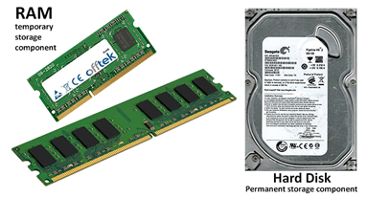

Storage devices are also used in the input and output functions, allowing data to be saved (output function) and then accessed again later (input function).
Examples
The following table lists a few sample actions along with the name of devices and functions that are used when they are performed.
Action | Device | Function
A user running a text-editor program types the letter Z on the keyboard. The keyboard sends a code representing the letter Z to the CPU | Keyboard | Input
The CPU processes the code and determines what letter was typed. Then the CPU sends instructions to the monitor to display the letter Z. | CPU | Process
The monitor displays the letter Z. | Monitor | Output
The user clicks the Save button. The mouse sends a code representing the click. | Mouse | Input
The CPU processes the code and determines what action was clicked. | CPU | Process
The CPU saves the file on the disk. | Hard disk | Storage

