**General Physics II**

PHY 102

Dr W. N. Igboama

Department of Physics

**Capacitors**

Are devices for storing electrical charge which can then be released in a controlled manner. Capacitors vary in shape and size, but the basic configuration is two conductors carrying equal but opposite charges + *q* and *–q*, that are separated, usually by a non-conducting material -an insulator.

Fig: Circuit symbol 

It takes work, which is then stored as potential energy in the electric field that is set up between the two plates, to place charges on the conducting plates of the capacitor. Since there is an electric field between the plates there is also a potential difference between the plates.

We usually talk about capacitors in terms of parallel conducting plates as shown in the fig below



They can be seen as any two conducting objects shown by the diagram below.



Applications of Capacitors in electronics

-storing electric potential energy,

-delaying voltage changes when coupled with resistors,

-filtering out unwanted frequency signals,

-forming resonant circuits and making frequency-dependent

and independent voltage dividers when combined with resistors

**Capacitance**

The capacitance is defined as the ratio of the amount of charge that is on the capacitor to the potential difference between the plates at this point.

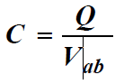

The units of capacitance are

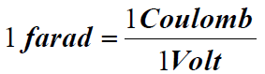

**Calculating the Capacitance**

We start with the simplest form –two parallel conducting plates separated by vacuum. Let the conducting plates have area A and be separated by a distance d.

The magnitude of the electric field between the two plates is given by

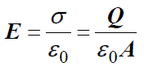

We treat the field as being uniform allowing us to write, that,

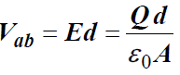

We also can describe capacitance based on the geometry of the

capacitor.

1. **For a parallel-plate capacitor:**

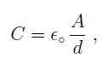

where A is the area of one of the plates (both plates have equal areas here), d is the separation distance of the plates, and εo is the permittivity of free space (a constant)

**For a Cylindrical Capacitor**

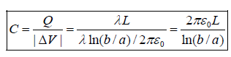

Where λ=*Q/L*= is the charge per unit length. Also a, b are the radii of inner and outer circles of the cylinder.

**For a Spherical Capacitor**



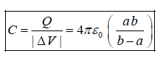

**For a single isolated spherical conductor of radius *R*, the capacitance is**



**Arrangement of Capacitors**

Sometimes in order to obtain needed values of capacitance, capacitors are combined in either Series or Parallel.

or 

Fig a:Series Fig b: Parallel

**Capacitors in Series**

Capacitors are often combined in series and the question then becomes what is the equivalent capacitance?

**Given**  two capacitors as shown in the below

What is the equivalent capacitance? 

Capacitors become charged because of potential difference Vab. If upper plate of C1 gets a charge of +Q, Then the lower plate of C1 gets a charge of –Q.

**What happens with C2?** Since there is no source of charge at point C2, and we have effectively put a charge of –Q on the lower plate of C1, the upper plate of C2 gets a charge of +Q



We also have that, the potential across C1 plus the potential across C2 should be equal to the potential drop across the two capacitors.



We have,

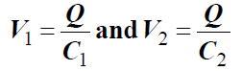

Then,

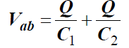

Dividing through by *Q*, we have

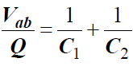

The equivalent capacitor will also have the same voltage across it

So we then have for the equivalent capacitance as

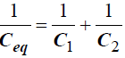

If there are more than two capacitors in series, the resultant capacitance is given by

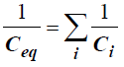

i.e. the sum of the reciprocal of each of the capacitances.

**Capacitors in Parallel**

Capacitors can also be connected in parallelas shown below.



The upper plates of both capacitors are at the same potential. Likewise for the bottom plates

We have that,



Now,

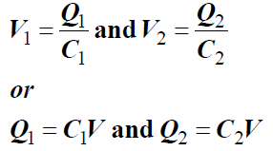

The equivalent capacitor will have the same voltage across it, as do the capacitors in parallel.

But what about the charge on the equivalent capacitor?

The equivalent capacitor will have the same total charge



Using this, we have,

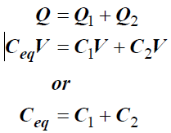

The equivalent capacitance is the sum of the capacitances of the two capacitors. If we have more than two, the resultant capacitance is just the sum of the individual capacitances.



**Example 1**

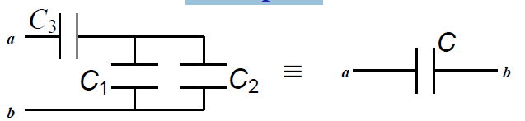

Recognize that *C*1 and *C*2 are parallel with each other and combine these to get *C12.*This *C12* is then in series with with *C3*

The resultant capacitance is then given by

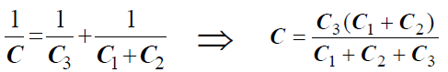

**Energy Stored in a Capacitor**

Electrical Potential energy is stored in a capacitor. The energy comes from the work that is done in charging the capacitor. Let *q* and *v* be the intermediate charge and potential on the capacitor.

The incremental work done in bringing an incremental charge, *dq*, to the capacitor is then given by



The total work done is just the integral of this equation from *0* to *Q*

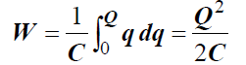

Using the relationship between capacitance, voltage and charge we also obtain

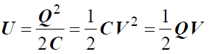

where *U* is the stored potential energy.

**Example 2**

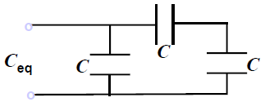

**What is the equivalent capacitance, *C*eq, of the combination shown?**

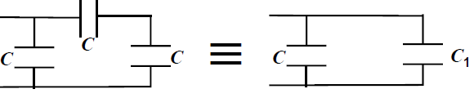

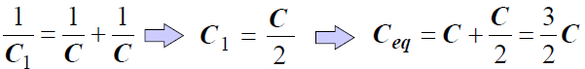

**Electric Field Energy Density**

The potential energy that is stored in the capacitor can be thought of as being stored in the electric field that is in the region between the two plates of the capacitor.

**The quantity that is of interest, is in fact the *energy density***

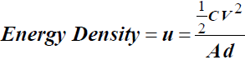

where *A* and d are the area of the capacitor plates and their separation, respectively.

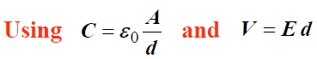

therefore we have,

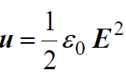

Even though we used the relationship for a parallel capacitor, this result holds for *all* capacitors regardless of configuration. This represents the energy density of the electric field in general.

**Exercise**

**One:** (a) Find equivalent capacitance of the arrangement below.

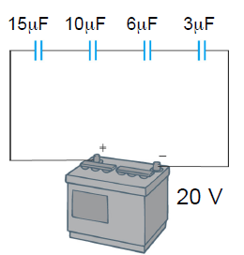

(b) Find Q on each capacitor:

(c) Find the voltage drop across each capacitor:

**Two:** The series combination of two capacitors shown in Fig. a is connected across 1000V. Compute (a) the equivalent capacitance Ceq of the combination, (b) the magnitudes of the charges on the capacitors, (c) the potential difference across the capacitors, and (d) the energy stored in the capacitors.

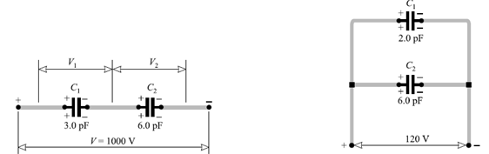

Fig.a Fig.b

**Three:** The parallel capacitor combination shown in Fig. b is connected across a 120V source. Determine the equivalent capacitance Ceq, the charge on each capacitor, and the charge on the combination.



Example: Find equivalent capacitance of the above arrangement.

1/Ceq =

1/(15μF)+1/(10μF)+1/(6μF)+1/(3μF)

= 0.667/μF

Ceq = 1.5 μF

Find Q on each capacitor:

Q = Ceq∆V = (1.5x10-6F)(20V)= 30µC

Find the voltage drop across each capacitor:

ΔV1 = Q/C1 = 30μC/15μF = 2V

ΔV2 = Q/C2 = 30μC/10μF = 3V

ΔV3 = Q/C3 = 30μC/6μF = 5V

ΔV4 = Q/C4 = 30μC/3μF = 10V

Notice that

ΔV1+ΔV2+ΔV3+ΔV4=ΔV



