**OPERATING SYSTEM (WINDOWS 7)**

**SOFTWARE**

The computer can do nothing until it is given INSTRUCTIONS called **software.**

Software is a set of instructions that tells the computer what to do. There are two types of software –

1. Operating System Software
2. Application Software

**What Does Windows Do?**

* Provides an easy way to start programs (the start button does this)
* Runs more than one program at a time ( called multitasking)
* Provides an easy way to switch between open programs (the taskbar does this)
* Provides access to internet (internet explorer does this)

**Operating System Software**

* Windows is Operating System Softare
* The OS controls and manages your computer by translating your instructions into a language your hardware understands. It links all different parts of your computer system together.
* Most computer come from the factory with an operating system pre-installed.
* The Windows OS is called a graphical user interface (GUI) because it uses pictures (icons) to help you communicate with the computer

**Windows Desktop**

The Windows desktop is the operating screen in Windows. It contains

1. Taskbar: a rectangular bar located by default at the bottom of the Windows desktop. It contains the Start button, the quick launch tray, the System tray, the system clock and a button for each program that is open. With several windows open , clicking on the program’s button on the taskbar is the most efficient way to bring the window you want to the front.
2. Icons: small pictures used to easily open program or document
3. Start Button: the button located at the left end of the taskbar that is used to open menus or programs

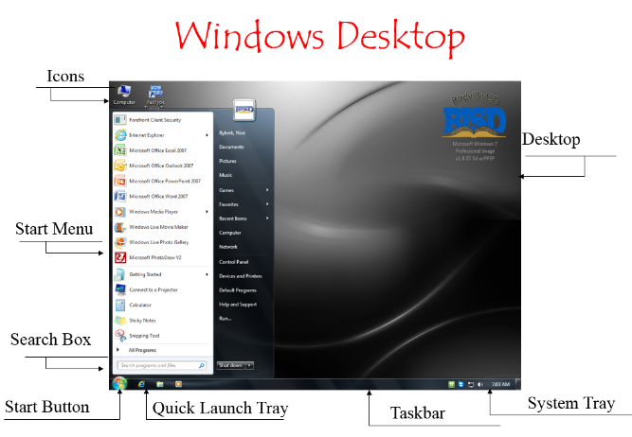

**FIGURE 1**

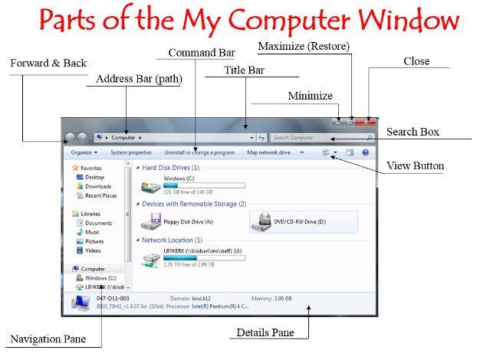

**FIGURE 2**

Windows Elements

* Window: A Window is a movable, resizable area in which information is displayed
* Menu bar: the menu bar is a row of words below the title bar. Each word displays a menu when clicked. (Not all windows have a menu bar.)
* Menu: a menu is a list of choices or options
* Title bar: the title bar appears at the top of the windows and displays the name of the open application or file

**Minimize, Maximize, Restore and Close**

At the right of the title bar are three buttons – minimize, maximize/restore and close

* Minimize: makes the window disappear from desktop and becomes a button on the task bar.
* Maximize: makes the window fill the screen.
* Restore: returns the window to its original size – ( the maximize and restore buttons toggle.)
* Close: makes the window disappears.

My Computer Window

* The My Computer Window (Figure 2) shows you the contents of your computer.
* Notice that the letter A represents the 3½ floppy drive and the letter C represents the hard drive of the computer

Files and Folders

* Files and folders are used to organize programs and documents in Windows.
* A file is a collection of text or data like a document or picture or sound.
* A folder is a container for programs, files or other folders. It is just an organizational device and can’t be printed or run or played.

Windows Accessories

In addition to being an operating system, Windows offers many kinds of built-in programs called Accessories. Some are located in the accessories folder and some are listed separately.

There are application for:

* Games: Solitaire, Chess, etc
* General Use: Calculator, Notepad, Paint, etc
* Entertainment: sound recorder, volume control media player, etc
* Communications: NetMeeting, phone dialer
* System tools: disk cleaanup, disk defragmenter
* Ease of access: magnifier, on-screen keyboard

Controlling Windows via the Mouse

Mouse: a small, hand-held device that is used to control the pointer on the screen.

There are seven main mouse actions:

* Point
* Click
* Right-click
* Double-click
* Drag
* Right-drag
* Scroll

Common Mouse Pointer Shapes and What They Do

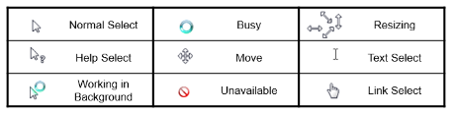

Controlling Windows via the Keyboard

* Keyboard: is used to enter data and to issue a commands to the computer

Keys on the Keyboard:

* Function Keys: the twelve keys located across the top of the keyboard that are labelled F1 – F12. They perform specific tasks depending on the software you are using.
* Control Keys: they are Shift, Ctrl, and Alt. They are used in combination with other keys to issue commands
* Keyboard Shortcuts: are key combinations (usually using Control Keys) that can be used to activate certain commands as an alternative to using the mouse. Examples are:
* New ……….Ctrl + N
* Open ……….Ctrl + O
* Save………...Ctrl + S
* Print……….Ctrl + P
* Cut…………Ctrl + X
* Copy……….Ctrl + C
* Paste……….Ctrl + V
* Select All…..Ctrl + A

Getting Help

Microsoft Windows has a built-in help feature. You can access the feature in several different ways:

* From the Desktop – click on the start button. The Help feature is the Start Menu
* Function Key – press the F1 function and the Held window will open