CHAPTER ONE
DEFINITION OF COMPUTER SYSTEM
Computer is an electronic device capable of accepting data through any input device such as keyboard, diskette, and scanner, processes it into meaningful information and produces it through an output device such as monitor which is also called (VDU) i.e. visual display unit.



CHARACTERISTICS OF COMPUTER
The following characteristics of computer system distinguish it from adding machine.
- It is electronic in nature: that is data are represented in form of electrical impulses
- High speed- It processes data at a high speed in order of nanoseconds (billionth of second)
- Stores and processes large amount of data
- Long term- It has ability to store information on long-term basis.
- It has very high sensitive memory- Once instructions are given to the computer it never forgets.
- Large storage potential
- It saves time, labour cost and increase productivity

Computer is fast becoming the universal machine of the 21st century. Early computers were large in size and too expensive to be owned by individuals. Thus they were confined to the laboratories and few research institutes. They could only be programmed by computer engineers. The basic applications were confined to undertaking complex calculations in science and engineering. Today, computer is no longer confined the laboratory. Computers and indeed, computing have become embedded in almost every item we use. Computing is fast becoming ubiquitous. Its application transcends science, engineering, communication, space science, aviation, financial institutions, social sciences, humanities, the military, transportation, manufacturing, extractive industries to mention but a few. This unit presents the background information about computers.
- Basic understanding of data processing
- The concept of data and information
- Methods of data processing
- Characteristics of a computer

Definition of the computer
Computer: A computer is basically defined as a tool or machine used for processing data to give required information. It is capable of:
a. taking input data through the keyboard (input unit)
b. storing the input data in a diskette, hard disk or other medium
c. processing it at the central processing unit (CPU) and
d. giving out the result (output) on the screen or the Visual Display Unit (VDU).
INPUT
PROCESSING
OUTPUT

(DATA) (INFORMATION)

Fig. 1.1: Schematic diagram to define a computer
Data: The term data is referred to facts about a person, object or place e.g. name, age, complexion, school, class, height etc.
Information: Is referred to as processed data or a meaningful statement e.g. Net pay of workers, examination results of students, list of successful candidates in an examination or interview etc.

1.2 Methods of Data Processing
The following are the three major methods that have been widely used for data processing over the years:
a. Manual method
b. Mechanical method and
c. Computer method.

Manual Method
The manual method of data processing involves the use of chalk, wall, pen pencil and the like. These devices, machine or tools facilitate human efforts in recording, classifying, manipulating, sorting and presenting data or information. The manual data processing operations entail considerable manual efforts. Thus, manual method is cumbersome, tiresome, boring, frustrating and time consuming. Furthermore, the processing of data by the manual method is likely to be affected by human errors. When there are errors, then the reliability, accuracy, neatness, tidiness, and validity of the data would be in doubt. The manual method does not allow for the processing of large volume of data on a regular and timely basis.

Mechanical Method
The mechanical method of data processing involves the use of machines such as typewriter, roneo machines, adding machines and the like. These machines facilitate human efforts in recording, classifying, manipulating, sorting and presenting data or information. The mechanical operations are basically routine in nature. There is virtually no creative thinking. The mechanical operations are noisy, hazardous, error prone and untidy. The mechanical method does not allow for the processing of large volume of data continuously and timely.

Computer Method

The computer method of carrying out data processing has the following major features:
i. Data can be steadily and continuously processed
ii. The operations are practically not noisy
iii.There is a store where data and instructions can be stored temporarily andpermanently.
iv. Errors can be easily and neatly corrected.
v. Output reports are usually very neat, decent and can be produced in various forms
such as adding graphs, diagrams, pictures etc.
vi. Accuracy and reliability are highly enhanced.
vii.Below are further attributes of a computer which makes it to be an indispensable tool
for human being.

1.3 Characteristics of a Computer
Characteristics of Computer
- Speed: The computer can manipulate large data at incredible speed and response time can be very fast.
- Accuracy: Its accuracy is very high and its consistency can be relied upon. Errors committed in computing are mostly due to human rather than technological weakness. There are in-built error detecting schemes in the computer.
- Storage: It has both internal and external storage facilities for holding data and instructions. This capacity varies from one machine to the other. Memories are built up in K(Kilo) modules where K = 1024 memory locations.
- Automatic: Once a program is in the computers memory, it can run automatically each time it is opened. The individual has little or no instruction to give again.
- Reliability: Being a machine, a computer does not suffer human traits of tiredness and lack of concentration. It will perform the last job with the same speed and accuracy as the first job every time even if ten million jobs are involved.
- Flexibility: It can perform any type of task once it can be reduced to logical steps. Modern computers can be used to perform a variety of functions like on-line processing, multi-programming, real time processing etc.

1.4 The Computing System
The computing system is made up of the computer system, the user and the environment in which the computer is operated.
The Computer System
The computer system is made up of the hardware and the software.
The Hardware
The computer hardware comprises the input unit, the processing unit and the output unit.

The input unit comprises those media through which data is fed into the computer. Examples include the keyboard, mouse, joystick, trackball, scanner etc.

The processing unit is made up of the Arithmetic and Logic Unit (ALU), the control unit and the main memory. The main memory also known as the primary memory is made up of the Read Only Memory (ROM) and the Random Access Memory (RAM).
The output unit is made up of those media through which data, instructions for processing the data (program), and the result of the processing operation are displayed for the user to see. Examples of output unit are the monitor (Visual Display Unit) and the printer.

Software
Computer software are the series of instructions that enable the computer to perform a task or group of tasks. A program is made up of group of instructions to perform a task. Series of programs linked together make up software. Computer programs could be categorized into system software, utility software, and application programs.

Computer Users
Computer users are the different categories of personnel that operates the computer. We have expert users and casual users. The expert users could be further categorized into computer engineers, computer programmers and computer operators.

The Computing Environment
The computing environment ranges from the building housing the other elements of the computing system namely the computer and the users, the furniture, auxiliary devices such as the voltage stabilizer, the Uninterruptible Power Supply System (UPS), the fans, the air conditioners etc. The schematic diagram of the computing system is presented in Fig. 1.2a. to Fig. 1.2e

The Computing System
Hardware
Software
Users
Computing environment
Fig. 1.2a: Schematic diagram of the computing system

Processing unit
Hardware
Input unit
Output unit
Keyboard
Mouse
Scanner
ALU
Control unit
Main memory
VDU
Printer
Fig. 1.2b: Computer hardware

Software
System software
Utility software
Application software
Operating system
Anti virus
Scandisk
Word processor
Spread
sheet
Statistical packages
Fig. 1.2c: Computer software
Computer users
Casual users
End users
Expert users
System engineers
Programmers
Computer operator
Data entry clerk
Fig. 1.2d: Computer users

Computing environment
Building
Furniture and fittings
Auxiliary devices
Air conditioner
Voltage stabilizer
UPS
Fig. 1.2e: Computing environment

HISTORICAL DEVELOPMENT OF COMPUTERS
1) Early aids of counting
The Abacus device was invented in 1617 to replace tradition method (finger/stones) for counting. The Abacus device is an instrument used for counting as far back as 500BC.This is done with objectives of making calculation easier and to suit various number systems.
2) Scientific Era
In 1642, Blaise Pascal ,a French mathematician invented first mechanical calculator. He also invented a programming language named after him.
In 1673, Gottfried Von Leibniz, a German mathematician invented another calculating machine. Men understood that this machine could hold mathematicians, businessmen save time and money.
In 1822, Charles Babbage built two enormous engines namely
i) Difference Engine
ii) Analytical Engine
In 1822, Charles Babbage built difference engine which could figure and mathematical tables. Next in 1833, he envisioned a machined which could complete programmed Arithmetic operation (addition subtractions, multiplication and division). He also imagines that the machine might be able to store or remember the results. He called this machines the Analytical Engine.
Hence, Charles Babbage is known as the father of the computer because of the ideas he introduced. The analytical engine has five parts
A) Store: It is used for holding data for the various calculations and the numbers generated
during the calculation.
B) Arithmetic Units
C) Control Unit: This was to organize the work in the correct sequence and control the
transfer of data from the store to the mill
D) Input Unit: For reading instruction and data from punched cards into the machine.
E) Output Device: For writing either on the punched cards or in the form of print
Herman Hollerith's Machine (1862-1929)
Herman Hollerith made the most outstanding and important mechanical device. The machine was used to processed information obtained in the census of the populations carried out in the United States in 1890.
He later merged with other companies to become part of the American computer company known as International business machine (IBM), the largest computer manufacturer in the world.
Howard Aikem (1944-mark 1)
A professor from Howard university, he developed a computer using modern electronics to perform mathematical computations .He blended the ideas of Babbage, and Hollerith's punched card methods into electromagnetic sequence controlled calculator.

Bill Gates and Allen Paul (1976)
They were interested in using the computer to learn /play games. Strategies particularly monopoly .they developed the first microcomputer (BASIC) programming language for the first commercial microcomputer.
Computers in Nigeria
The electronic computer made its advent into Nigeria in 1963 during the national census. Same year, International Business machine (IBM) world trade corporation in collaboration with the university of Ibadan established as IBM African Education center to promote the use of modern data processing methods in Africa through such a training programmed.

COMPUTER GENERATIONS
The invention and development dates of each computer generation are listed below with their corresponding technological base
- first generation - vacuum tubes (1946)
- Second generation - Transistors (1955-1964)
- Third generation -Integrated Circuit (IC) (1964-1972)
- fourth generation - Large Scale Integrated Circuit (1972-1987)
- fifth generation -Knowledge based system (AL)(1990-to date)
First generation of computer System
They were based on vacuum tubes. They are very large in size and require a very elaborate air conditioning system. It was invented in 1946. In 1946, a machine called ENIAC (Electronic Numerical Integration and calculator) was built in America for calculation. This was the first general purpose digital computer other computer that was developed during the first generation of computers includes EDSAC (Electronic Delay Storage Automatic Computer) which was based on the idea of stored program concept
This was followed up by the design and building of ACE (Automatic Computer Engine) and EDVAC (Electronic Discrete Variable Automatic Computer).
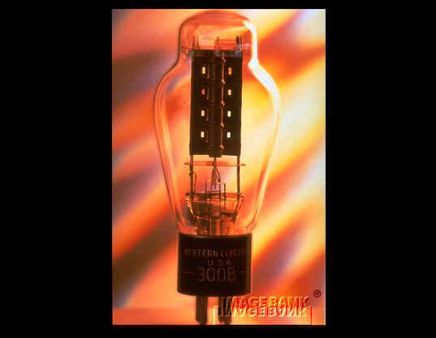
Figure 1: Vacuum tube
The following are features of first generation of Computer System
- They are very huge computers
- They are expensive and have high power consumption.
- They are slow and often reliable
- Finally , they have limited internal memory
Second generation of computers
They are made from a tiny electronic component called transistor. During the second generation of computers, computers with large memories and fast processing speed were developed to perform calculations, multi-programming with the use of high level languages Example include IBM 7000series IBM( International Business Machine) .
Characteristics of second generation of computers
- They have faster input/output
- They are free of heat problems
- They are cheaper, smaller, and lighter compare to first generation of computers
- They use symbolic language like Assembly language
Third generation of computers
Introduction of integrated circuit (IC) took place during the second generation of computers. It consists of a number of individual electronic components (transistors, resistors, capacitors) that are fused together to form a single small component using paper thin slices of silicon known as silicon chips. They consumed less power, smaller in size and much more reliable. Computers of this era includes IBM 350series, UNIVAC 1108.
UNIVAC- Universal Automatic computers
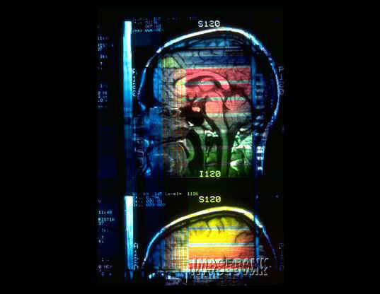
Figure 2: Integrated circuit
Fourth generation of computers
This generation of computers used large scale integrated circuits (LSI) and very large scale integrated circuit. They accommodate about 5,000m circuit element ( i.e transistor and resistor) on 1.3 cm square of silicon which complete Arithmetic Logic unit (ALU) of microcomputer central processing Unit (CPU) which could be packaged on a single chip called microprocessors features of fourth generation of computers
- It is powerful, small and cheaper
- It consist of CPU (central processing Unit) and ALU (Arithmetic Logic Unit) fifth generation of computers
These generations of computer system are expected to take decisions and communicate with users in natural languages. Global networking i.e. Internet technology is another expected features of the fifth generation of computers.

CHAPTER TWO
TYPES OF COMPUTERS
There are three main types of computers
(1) Digital computers
(2) Analogue computers
(3) Hybrid computers.
Digital computer
The word digital means whole number. These computers operate on the basis of counting quantities or amounts, which are then processed arithmetically. Examples of digital computers are: calculators wrist watches Features of digital computers:
a) It is electronic
b) It is two states values i.e. o and 1
c) Values are discrete
d) It has stored program

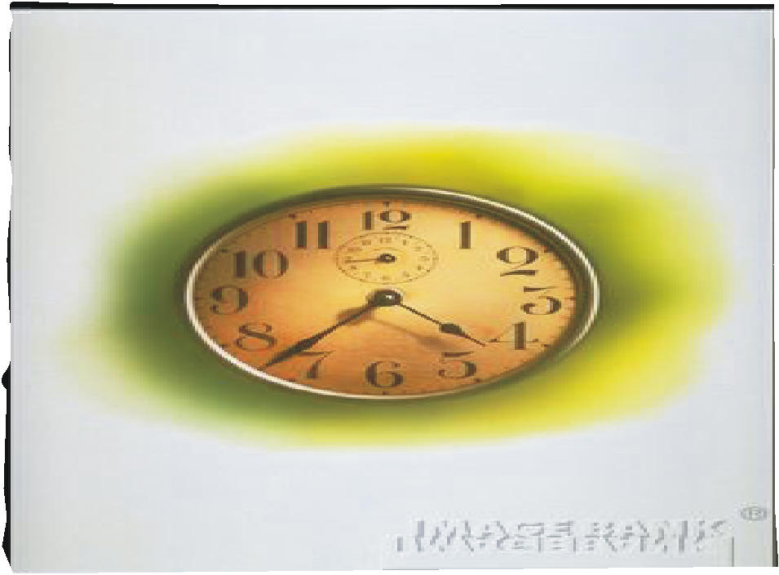
Figure 3: Analogue computer
An analogy device operates on continuous valves by accepting data as a quantity over a length of time. Example includes thermometer and petrol dispenser at the filling stations.
Another example is volume control on television set and speedometer. This is because it allows the volume to be adjusted continuously.
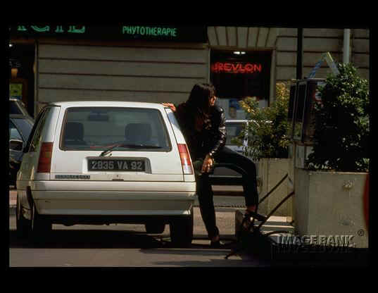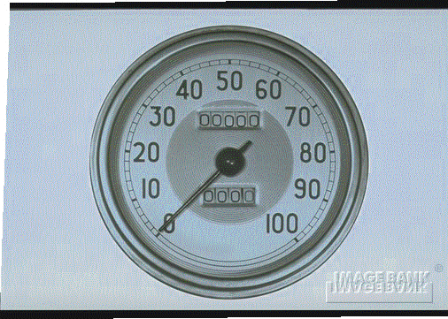
Petrol dispenser Speedometer
The features of analogy computer are as follows
(a) Values are continuous.
(b) Components are linked
(c) Output occurs immediately
Hybrid computer
It combines both the features of digital and analogue computers. It is used in specialized applications such as industrial process control when both kinds of information are needed to be processed. Example is a robot used in industrial environment. Another example is setting or programming on a modern day television set. This involves both digital and analogue.
Computer classification by size
The physical size can be used to classify digital computers into four classes
1) Super computers
2) Mainframes computers
3) Minicomputers
4) Microcomputers
1) Super Computer: These are the largest, fastest and most expensive computers. Its cost is several million of dollar and the speed is between 400-600 million instructions per second. They are usually used for complex computations by scientist in areas such as oil exploration and forecasting graphics.
2) Mainframe: A mainframe computer is a large and expensive general purpose computer. They have large internal memory with high processing speed. It supports a lot of peripheral equipment such as printers.
Examples are IBM 360/370 system
Features of Mainframes
a) They are first generation of computers
b) They are large, powerful, expensive and enormous capacity
c) Mainframes require elaborate installation procedures.
3) Minicomputer: These computers have smaller physical size, generate less heat than the mainframe. Mini computers are less expensive, easier to install and operate. Size of their internal memory is usually between 128 megabyte. Example are DEC, IBM system
4) Micro computers: Micro computers could be regarded as personal computers because one person can work with it at the same time. Examples are desktop, laptop
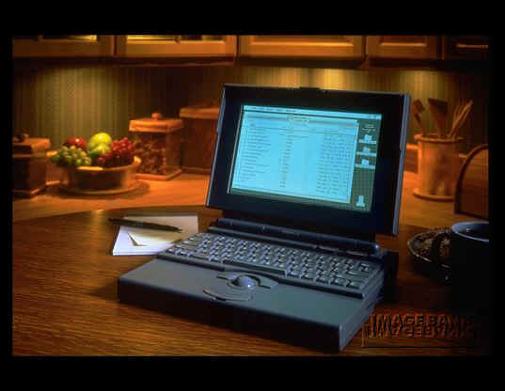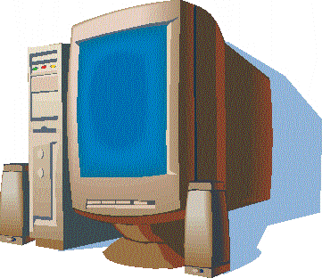
Laptop Desktop
Basic components of a computer system
A computer system consists of two basic components and often the third-human beings, namely:
(A) Hardware.
(B) Software
(c) People wares
Hardware
This is described as electromechanical parts of a computer system. The hardware is actual computer, because it consists of all the various physical components and devices brought together to build a physical computer. The computer hardware can be divided into two main units thus:
1. The central Processing Unit (CPU)
2. The peripheral

Central Processing Unit
The Central processing unit is responsible for all processing that occur with the computer while the peripherals are responsible for feeding data into the system and for collecting information from the system.
(1) The central Processing unit:-
This consists of three functional parts namely:
(a) Main Memory Unit
(b) Control Unit
(c) Arithmetic and Logical Unit (ALU)
Arithmetic and Logic Unit
As one boots the computers places a disk in the drive, the CPU transfers the program from the disk into the high speed internal memory where the program takes control of the CPU. The CPU shifts the data to and fro the disk into the internal memory in order to process it
Main Memory
It is computer memory. It is computer memory. It is also called the internal memory. It is called the internal memory. It is used for storing data to be processed as well as the instructions required during processing period. It also stores intermediate results of processed data. The memory consists of storage cells called bytes. It can hold information temporarily i.e while the operation is in progress, once the operations runs to completion or there is power failure, whatever information or data that is in the memory is lost automatically
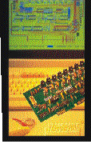

Arithmetic and Logical Unit (ALU)
This is where all arithmetic and logical operations are performed. It contains electronic circuits to perform arithmetic operations like addition, subtraction, multiplication, counting and logical operation like comparison, movement of data. It works exclusively on binary and coded instructions.
Control Unit
This is the heart of the entire computer system. It is here that the co-ordination of the system's activities is carried out including the control of other peripheral devices. It fetches data from the memory, interprets them and directs flow to ALU and other peripherals- inputs/output device.
The peripherals
The peripherals are in categories namely; input devices, output devices and auxiliary storage.
Input Devices
They are used for supplying data into computer for processing. They convert input data into the readable forms. Examples are : Keyboard, Mouse, joystick

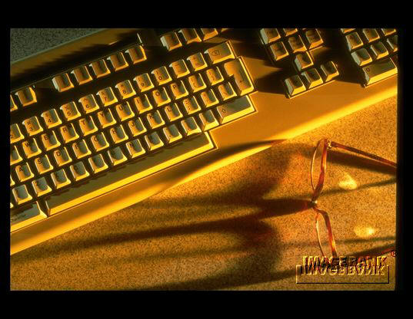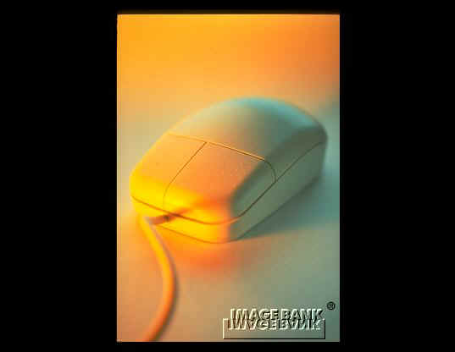
Output Devices
The result of processing is either as printed result or information data for future processing. The two most common output devices: Visual Display Unit (VDU) and computer printer.
Auxiliary Storage Devices
These are external memory used to permanently store data and information. They come as stand-alone devices that can be attached to the input and output units of the computer system. Example are diskette, flash drive and computer CD

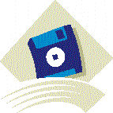 Diskette 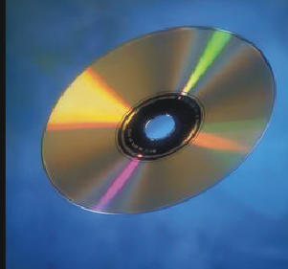 Compact disc

The System Unit
This is the case that makes up the computer. The case has both the front and back sections

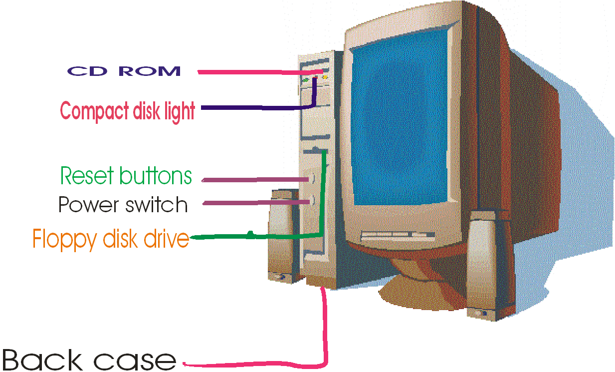

1) The front casing consists of:
a) Power switch
b) Reset buttons
c) Floppy disk drives
d) Power Light
e) CD ROM drives
f) Hard disk light
g) Key lock
h) Compact Disk Light
2 ) The back case has:
1) The ports: These are sockets for external device
2) Cords as: Power cords and Monitor Cords
3) Contents of the unit system. It holds the major components of the computer and contains
(a) Mother board (b) Expansions cord (c) Power Pack
(d) Drives
The motherboard: It is simply defined as: A rigid, slotted board upon which other boards that contain the basic circuitry of a computer can be mounted
The mother board are often classified according to the CPU they carry, such as:

Mother board

(a) 486-DX4 Mother board
(b) Pentium -230 MHZ
(c) Pentium 233 MHZ
(d) Pentium 2000MB

Input Devices
They are devices used to convert and transfer data/instruction into electronic form for input into the computer. To input means to "put in data, instruction or information. Some of these devices Include:
i) Keyboard. This is the most commonly used device for entering /encoding data into the computer . The standard Keyboard as 101 keys. They encode data by depression that the cause generation of selected codes/elements . It is like the typewriter keyboard with slight differences.
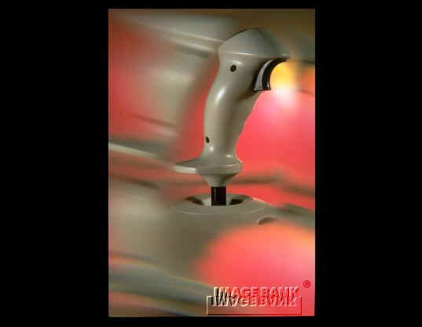
ii) The mouse

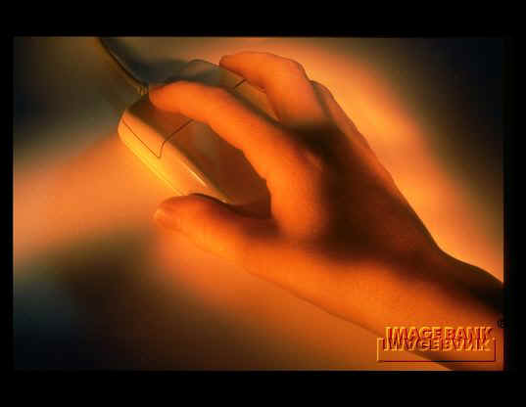
Double clicking is a mouse technique

Mouse is used for selecting and clicking icons and menus on the screen of the computer system
iii) Joysticks/tracker balls
They are used in computer games to point, select and move objects on the screen

iv) Scanners
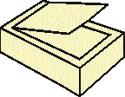
These devices read printed, written, photographic images and convert them into digital form that the computer can interpret. It is mostly used for printing posters, calendars, invitation cards e.t.c

Output Devices
The Visual Display Unit: The Visual Display Unit (VDU) also called the monitor is a television like device, which uses the cathode Ray Tube (CRT) to display result of the processing on the screen in alphanumeric form as well as graphical form.
There are two types of monitor screen
- The monochrome

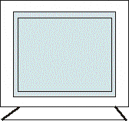

This display only one color that is the dark color and
(2) The color monitor which displays text, and graphics and picture in many colors
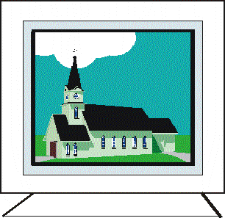

Printers
Printers are devices that display permanent output or result of the processing done by the computer.

Printers can be classified into categories
Impact printers
Non-impact printers.
(a) Impact printers
They work by applying pressure against ribbon onto the paper like a typewriter. The contact or impact transfers ink from the ribbon to the paper to form the image. They can in turn be classified according to their ability to print one character, work, line or page at a time.
(b) Non-Impact Printers
They work by producing images without any physical contact being madder on the paper .This category of printers includes the following:
(1) Inkjet /DeskJet Printers: They are very fast. Characters are formed on the paper by electro statically spraying the paper with a stream of ink drops (from a barrel/vial) in the shape of the characters (A, B,C,1.2,3,) required. They contain different colors good graphics and are commonly used in business centre, schools e.t.c. It is however slower than laser printers.
(ii) Laser Printers: They operate like photocopiers except that they use a laser beam to produce characters on the drum. Image are scanned on the reflected photo-conduction drum (on which toner powder is poured) which rolls over the paper. Printing is according to the following stages:-
Computer Storage/ Memory Devices
Computer memory is made up of the main memory and secondary memory. The main memory/primary memory is divided into two
(1) Random Access Memory (RAM) and
(2) Read Only Memory (ROM)

Secondary Storage
The following are secondary storage
Magnetic Disks
They are flat circular sheet of metal coated with magnetic oxide for storing data/information. Examples include floppy Diskettes, Hard disks and exchangeable disk pack.
(a) Floppy Diskettes:
They are used in microcomputers. They are made up of flexible plastic coated with magnetic oxide and enclosed in a rigid plastic case. The floppy diskette is the most common and can hold about 300 pages of a document. There are two types of diskettes
(1) 3.5 inches diskettes with capacity of 1.2Mb
(2) 5.25 inches diskettes with capacity of 1.44Mb
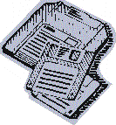

(b) Hard Disk:
Hard disk has a read and writes heads that reads or writes data from or on the disk as it rotates. Hard disk comes in different speeds and storage capacities ranging from 2000Mb (2Gb), 10Gb, and 20Gb e.t.c. The computers speed is measured based on the number of circles of operations carried within a period of time. They are faster than floppy diskettes.
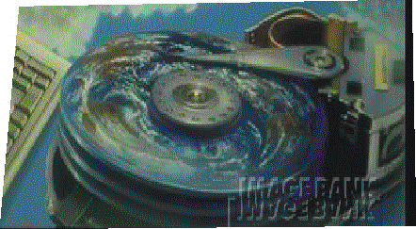

(ii) Exchangeable Disk Pack: These are used in mini-computers and mainframes. They are of 14 inches diameter and can contain from 8-10 disks. Their storage capacity range from 10Mb to 40GB and the disks can spin up to 200 kilometer/hour and can be accessed randomly/directly not sequentially.
(iii) Compact Disc (CD):
This is referred to as Laser Disc. They are non-magnetic disc on which enormous amount of digital data/information are stored. Data/information (which could textual, audio, graphical) can be written on the disc by burning microscopic pits into the reflective surface of the disc with a powerful laser. This is in form of binary digits of 0 and 1. This information is in turn read by laser which passes over the disc as it spins reflecting and converting into useful and meaningful form.

There are three types of compact disc namely:
- Compact Disc-Read Only Memory:
This is also referred to as the CD-Rom. It is now the most popular storage medium and can store 650Mb or an equivalent of 162,500 pages of information. Latest CD_ROM's can even hold up to 1.25Mb.
- Write once read many times (WORM):
These are essentially blanks which users can record data for the first time permanently without erasing it but it can be read many times.
(c) Erasable Optical Disc: Recorded data can be erased to be replaced by new data.
(d) Digital Video Disc (DVD)/Video compact disc (VCD): This technology makes it possible for more data/information to be packed on one disc than the conventional disc. The DVD/VCD drives use infrared to burn the microscopic pits in a double-layered reflective surface. To read, data the infrared laser reads the double-layered pits on the discs and reflects back the digitized sound, video.

CHAPTER THREE
COMPUTER PACKAGES

Computer Software
Computer Software is a collective name used to describe all types of computer programs that are executed by the system irrespective of what it is designed to do. They are basically programs that enable the hardware to function effectively as well as provide very many useful services.
The computer software is divided into two parts which includes
1) System software
2) Application software
System software
These are computer programs designed for effective management of the hardware and its peripherals which includes:
- Processor
- Memories
- Input and output devices etc to ensure optimal utilization of these resources to get best out them. They are also designed to simplify the uses of the computer system as a whole. These programs have essential functions of controlling and co-ordinating the different operations of the whole computer system. It is to be noted that the consequence of not having those programs will be what is technically known as deadlock operations in which no operation will be carried out.
The system software comprises of three main software/programs
(a) Operating system
(b) Utilities Software/programs
(c) Language Translation programs
Operating system
They are special program that tells the computer how to manage the various hardware units. They manage, coordinate and control the activities and resources of the computer. They specifically:-
i) Fetch data from the keyboard and other input devices.
ii) Control the operations of the Central Processing Unit by providing a
suitable environment for running application software.
iii) Send data/output to the video display unit/monitor, printers and output
devices.
iv) They file and retrieve data from the backing storage (CD-ROM, Floppy Diskette) and keep tract of memory allocation in the computer memory.
It is also responsible for communication and contains millions instruction. Example of operating system include: UNIX, Macintosh OS, MS-DOS (Microsoft Disk Operating System)
Application Software
This class of software is designed mainly to solve users problems rather than the systems. Their main focuses are the different fields of human endeavour (professions) for computer application aid to simplify the jobs. For example; Secretarys duties which include; documentations of letters, therefore a word- processing application programs comes handy for editing of documents and storage. This no doubt makes the job of the secretary more modern and easier which in turn increases efficiency of the secretary Also other area like; Accounting, Financial analysis, Personal management. Application software may be User- developed or acquired package by the manufacturer.
Software category Commerical Brands (trade name)
Speadsheet Lotus 1 , 2 , 3 Microsoft excel
Word- Processing WordPerfect, Microsoft word ,Word star
Desktop publishing Adobe page maker, Microsoft Publisher
Database Microsoft access Dbase IV
Graphics Corel Draw , Microsoft PowerPoint
Accounting Netscape Navigator, Internet
Communication Explorer
Designs Auto cards

(a) Computer /machine/Programming language: Computer program are written in specialized languages which the computer understands and interprets. It is based on binary code and a combination of human language; Some of these machine Languages are listed below
Future/natural Language 5Th generation language
Application Generators 4th generation Language
Query Language 3rd generation Language
Assembler Language 2nd generation Language
Low level language 1st generation Language

- Machine language was written using binary code 1 and 0 or on/ off to represent a set of instructions.
- Assemble language was written using simple mnemonics to represent each instructions e.g. DIR for Directory, DEPT for Department, DOS commands were developed using the programming languages.
- Procedure oriented Languages use instructions similar to Mathematics and English.

(b) Language Translation programs. They include interpreters or compliers that facilitate the translation of high level language to machine language
Functions of Some Commonly Used Application Software
1) Word Processors
They are programs designed to input, store and retrieve text. They are used to create and manage text by allowing the entry, editing, formatting, storing/ retrieving, alteration and printing of documents containing texts and sometimes tables, charts and graphics.
2) Spreadsheets
These are programs that display a grid containing data in form of figures, text, formulae and whose function is to enable various mathematical, statistical calculations to be done in budgeting, forecasting, business, financial planning e .t .c
3) Database Management Software (DBMS)
Database management software creates and maintains database. A database is a collection of files/records containing related information.
4) Graphical Software
Arts and Illustrative Graphic Software are used for drawing . This type of program can be used to draw symbols, objects, people, plants and animals. Example is Coreldraw.

APPLICATION OF COMPUTER PACKAGES
Computer Application in Education
Computer finds it place of relevance in educational sector for the following reasons.
1) Computer Assisted Instruction (CAI): This involves use of computer as medium to facilitate teaching and learning of any subject. The computer assist teacher by supplying regular lesson materials, help students to resolve many problem without requiring the full time participation of the teacher or some other persons.
2) Law and Order: Computer has increasingly become indispensable in the maintenance of law and order. Law enforcement is made possible with the use of computer generated videos and closed television system to detect crime suspects. Matching of finger prints of suspected offender is also made possible with the use of the computer.
3) Engineering and Architecture: - Engineers and Architects use Computer Aided Design (CAD) in the design and construction of bridges, houses, machines, automobiles as well as in determining their strength and ability to withstand extremities of climate before their actual construction
4) Computer in health: - The introduction of computer into the world of machines has greatly enhanced the Computerized Axial Topography that provides accurate detailed and precise diagnosis treatment of illness. Electro cardio graphic equipment can also be used to dictate heart beat cycles, scan functions of organ and monitoring patient temperature.
Hospital management system can be used to keep track of bed assignment, record instruction regarding machine of every patient and print at the hospital pharmacy designating proper drugs and dosage for patients as well as time and manner prior to each meal.
5) Office Automation: A typical office requires a lot of document and data processing which are tedious and time consuming. Computer alleviates this difficult task through: production of document, handling of voice, text, data, email, telecommunication and Management Information System (MIS) in organisations.

